Launching instances with Cloud-init

* Configuring Security group for a Webserver.

1. Open the Amazon VPC console at <https://console.aws.amazon.com/vpc/>. In the navigation pane, choose Security Groups. Enter a name of the security group and provide a description. Select the ID of your VPC from the VPC menu. Under Security group rules, provide inbound and outbound rules required for a webserver and choose Yes, Create.

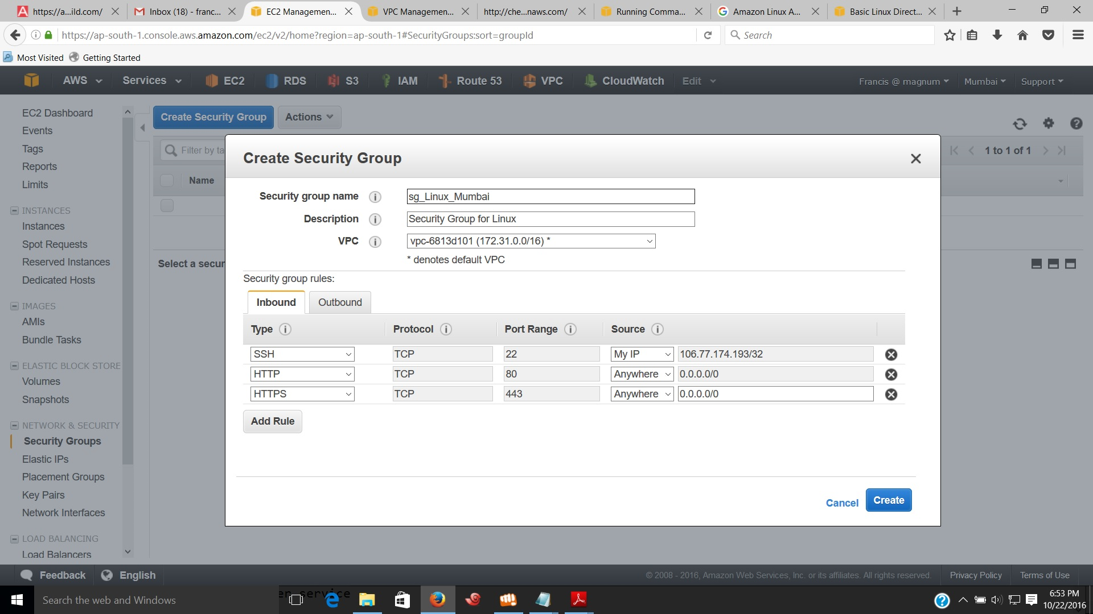

1. Select newly created Security Group and verify the rules.

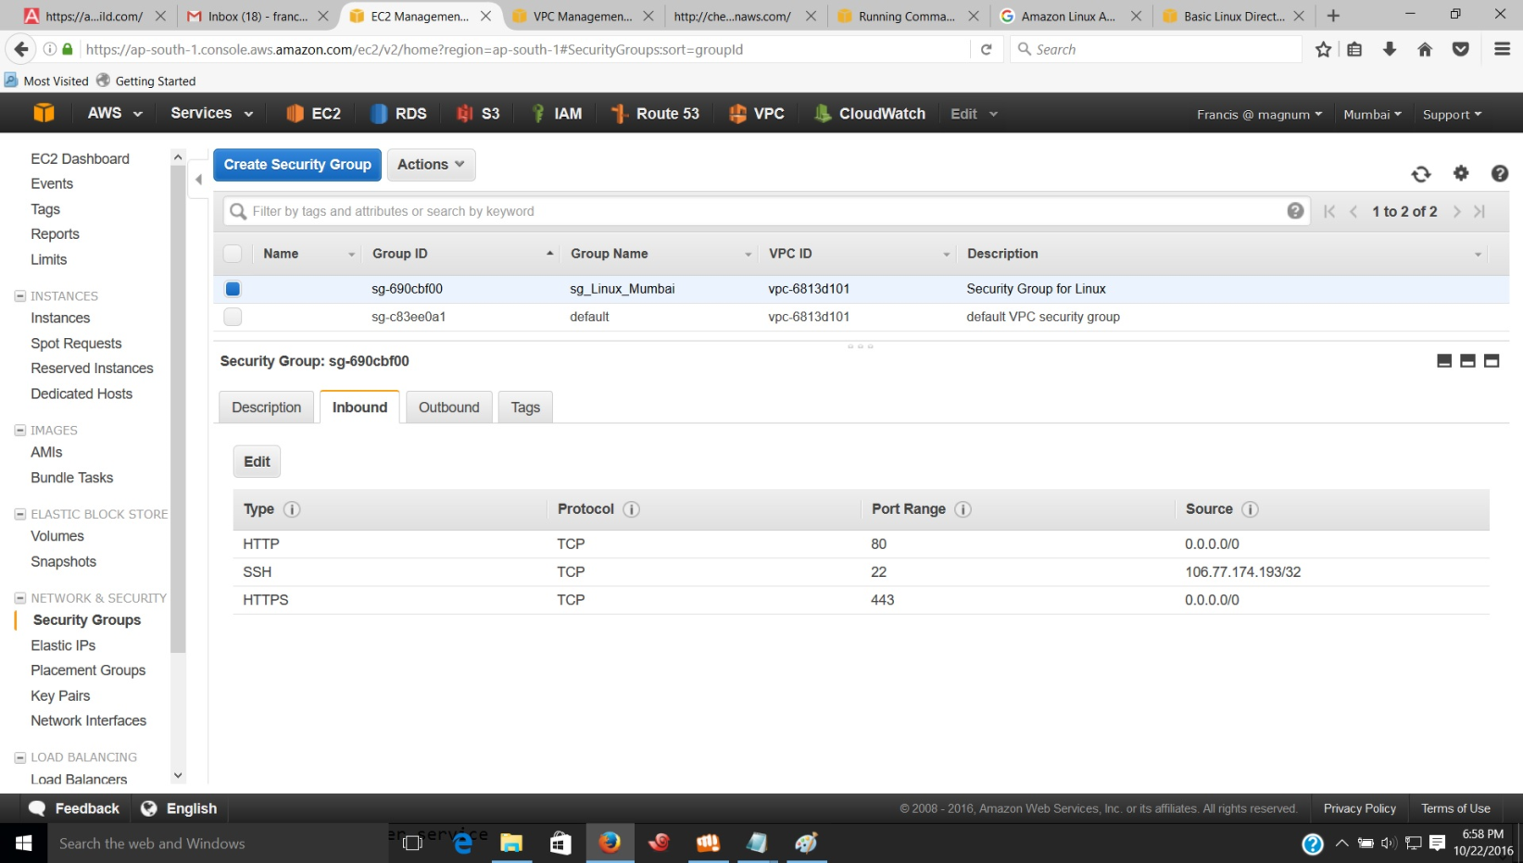

* Steps to Launch an EC2 Instance with Cloud-init

1. Open the Amazon EC2 Console from the dashboard and choose ‘ Launch instance ‘ and select an Amazon Machine Image that supports Cloud-init.
2. Select an Instance Type on ‘ Step 2 : Choose an Instance Type ‘ page and click on “ Next : Configure Instance Details. “
3. On ‘ Step 3 : Configure Instance Details ‘ page modify the settings as required. Then provide the Cloud-init Directives into the User data filed to perform automated configuration tasks such as running scripts after starting the instance.

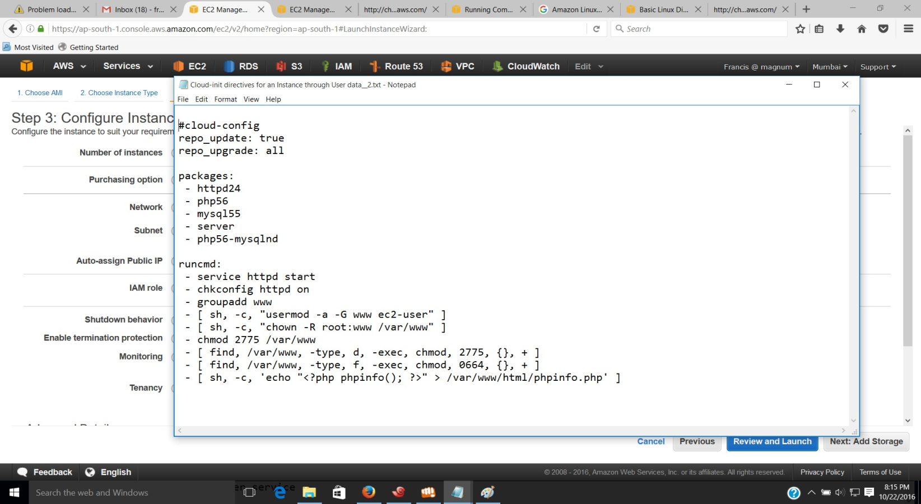

As an alternative, after modifying configuration settings you can fill Shell script into the user data field instead of Cloud-init Directives. This script performs same automated configuration tasks such as Cloud-init Directives.

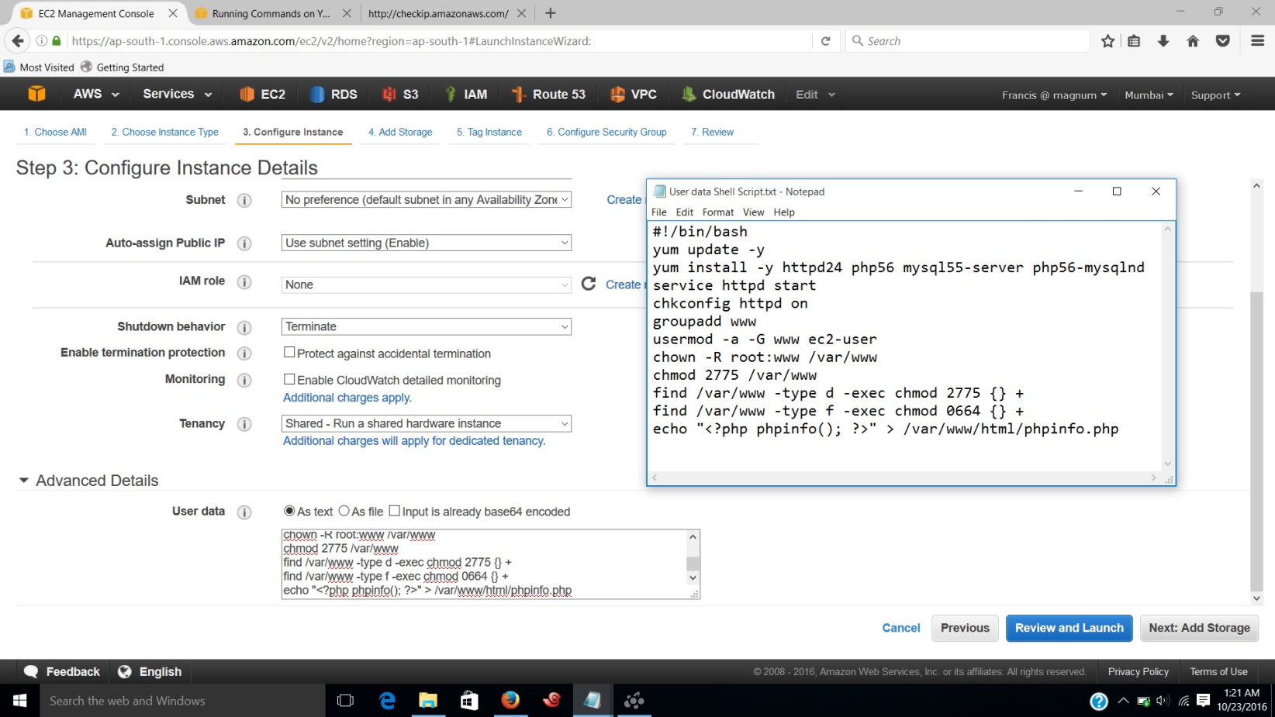

1. On ‘ Step 4: Add Storage ‘ page, specify volumes to be attached to the instance besides the volumes specified by the AMI.
2. On ‘ Step 5: Tag Instance ‘ page, specify [Name](http://docs.aws.amazon.com/AWSEC2/latest/UserGuide/Using_Tags.html) for the instance. Choose “ Next: Configure Security Group “ when you are done.
3. On the “ Step 6: Configure Security Group “ page, choose the security group you have created to define firewall rules for your instance.

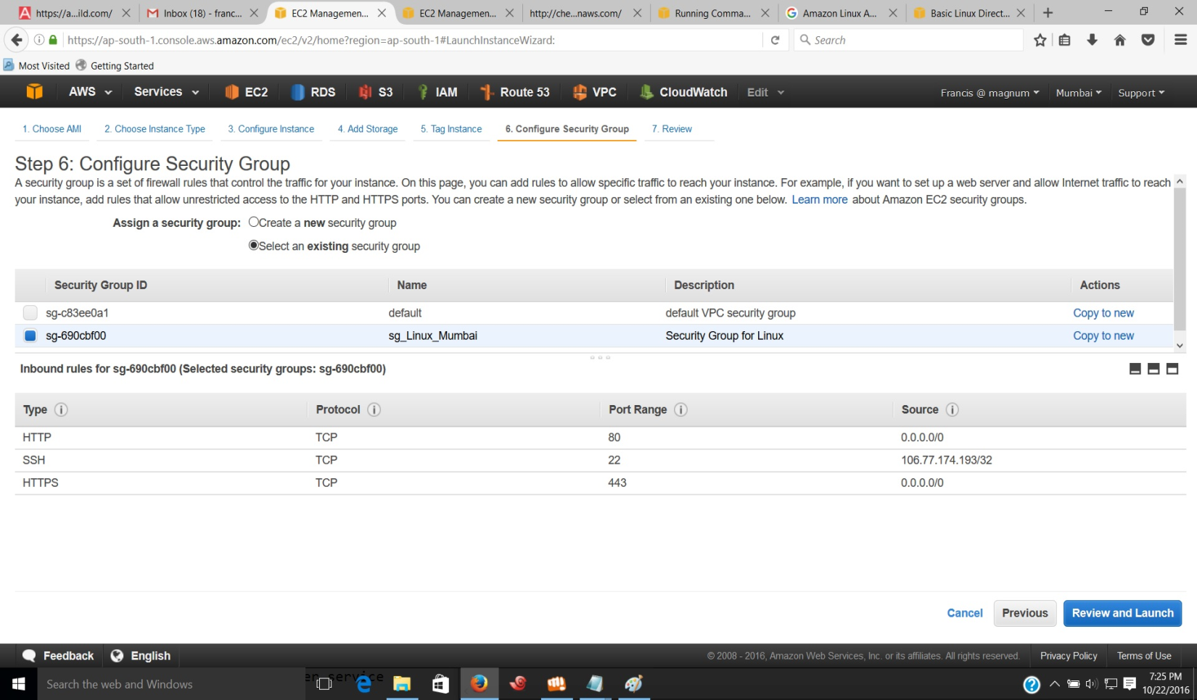

1. In ‘ Step 7: Review Instance Launch ‘ page, check the details of your instance, and make any necessary changes by clicking the appropriate Edit link. When you are ready, choose Launch.

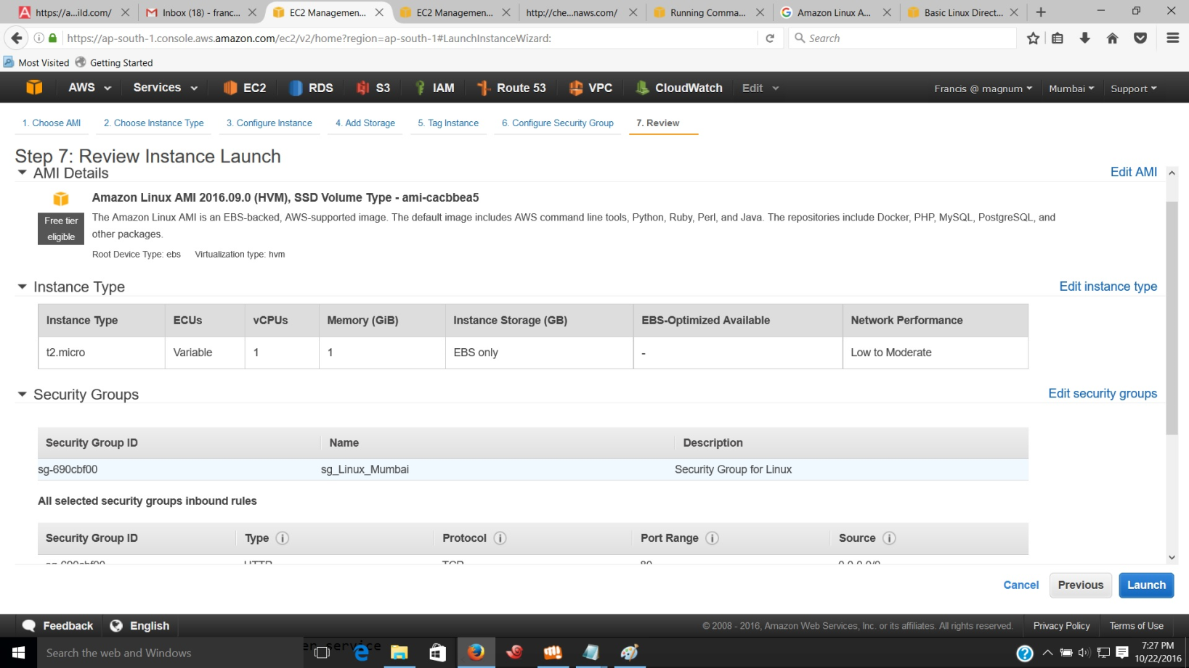

1. In the ‘ Select an existing key pair or create a new key pair ‘ dialog box, provide key pair information and click on “ Download Key pair. “ Save the Key pair in a secure location. Then click on ‘ Launch Instance.’
2. In the launch status page, id of launching instance is shown.
3. Click on the Instance id and you can see the details of the instance.

* Verifying whether Cloud-init directives completed the tasks.

1. You can verify whether Cloud-init directives completed the tasks by entering urls.

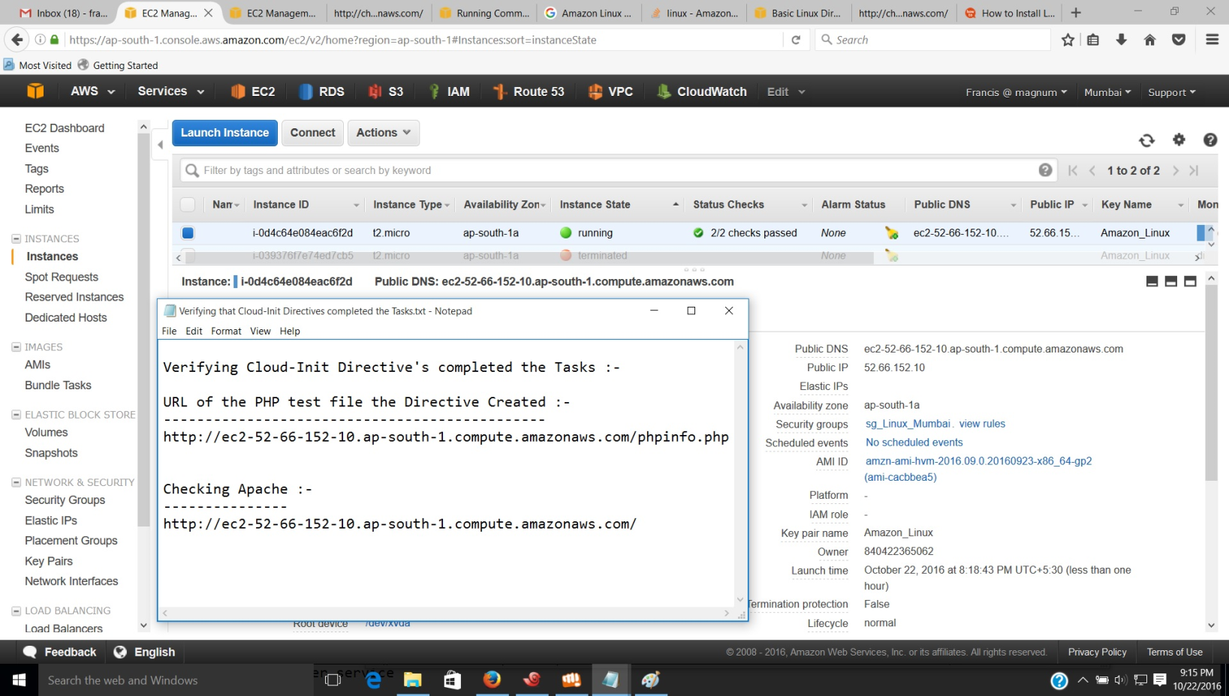

1. Enter the URL of the PHP test file the directives created. It is the public DNS address of your instance followed by a forward slash and the file name of PHP test file.

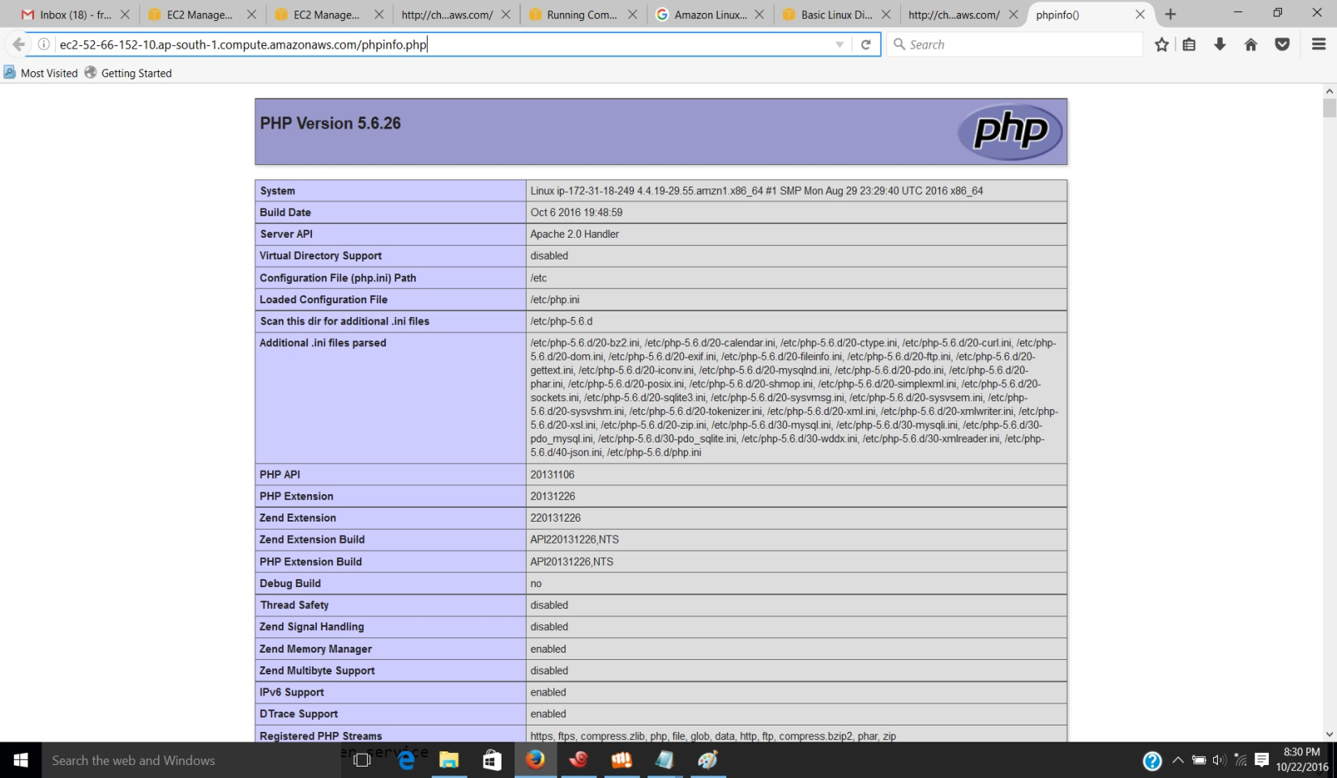

1. Verify the location of the PHP test file by connecting to the Instance and going to the path of test file.

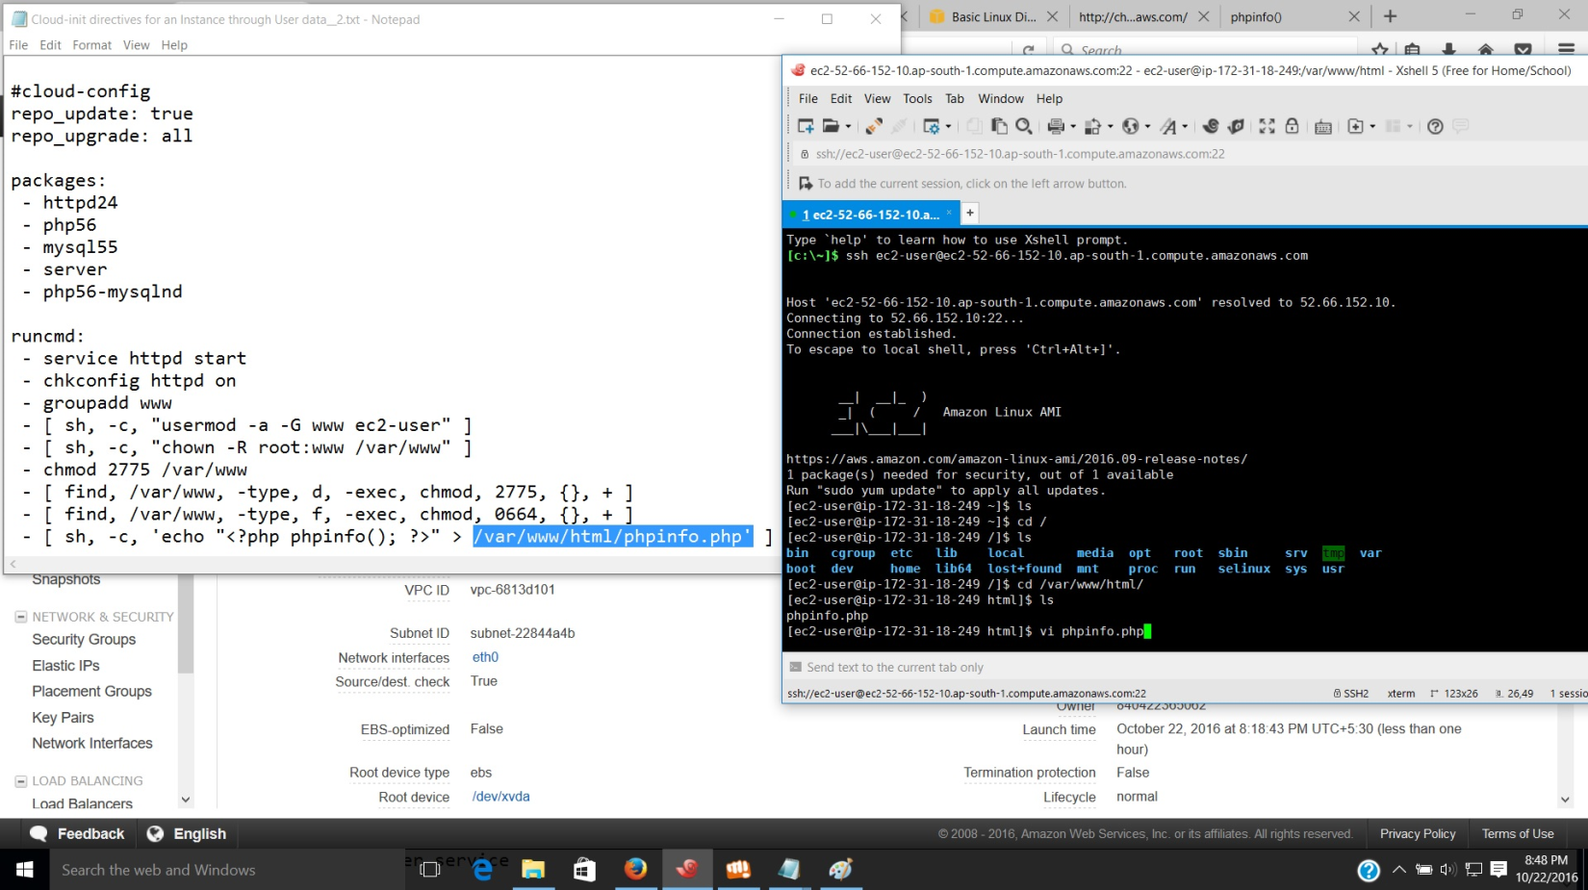

1. Run the code in PHP without the need for creating a file.

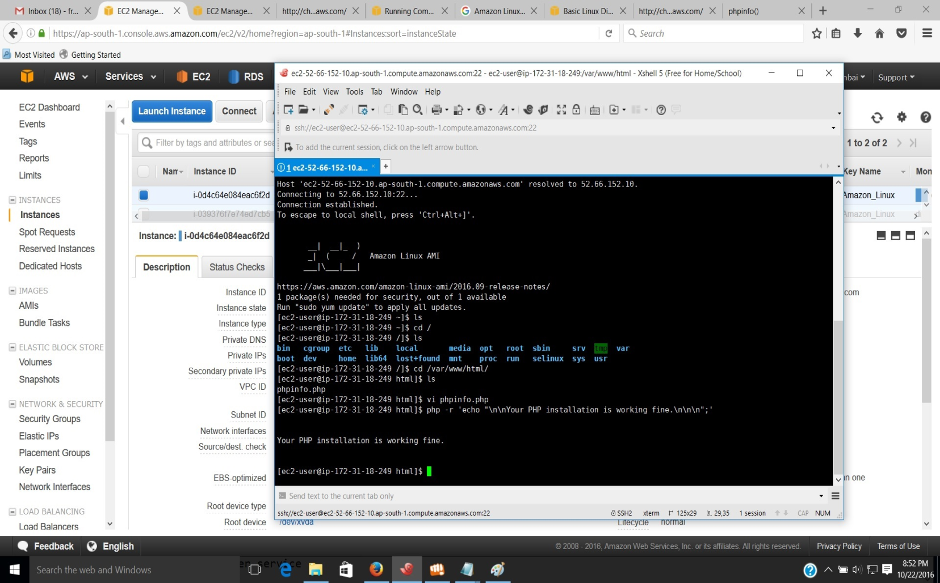

1. Test page of Apache http server.

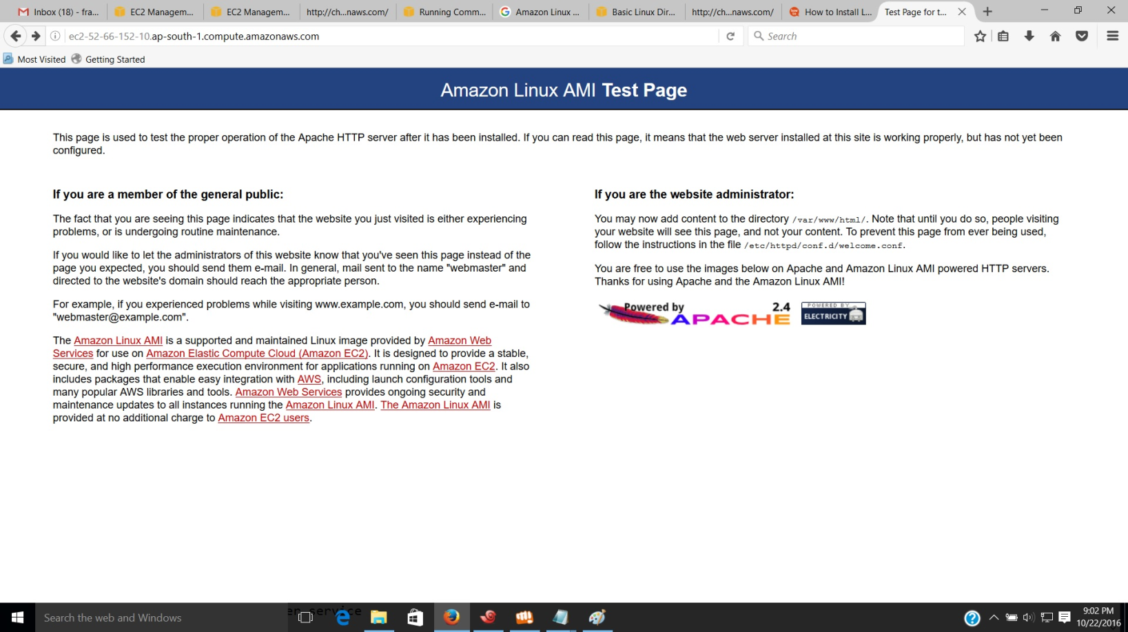

1. Restarting Apache2 after installation of after the installation of both MySQL and PHP.

